The Bluegrass Blondies

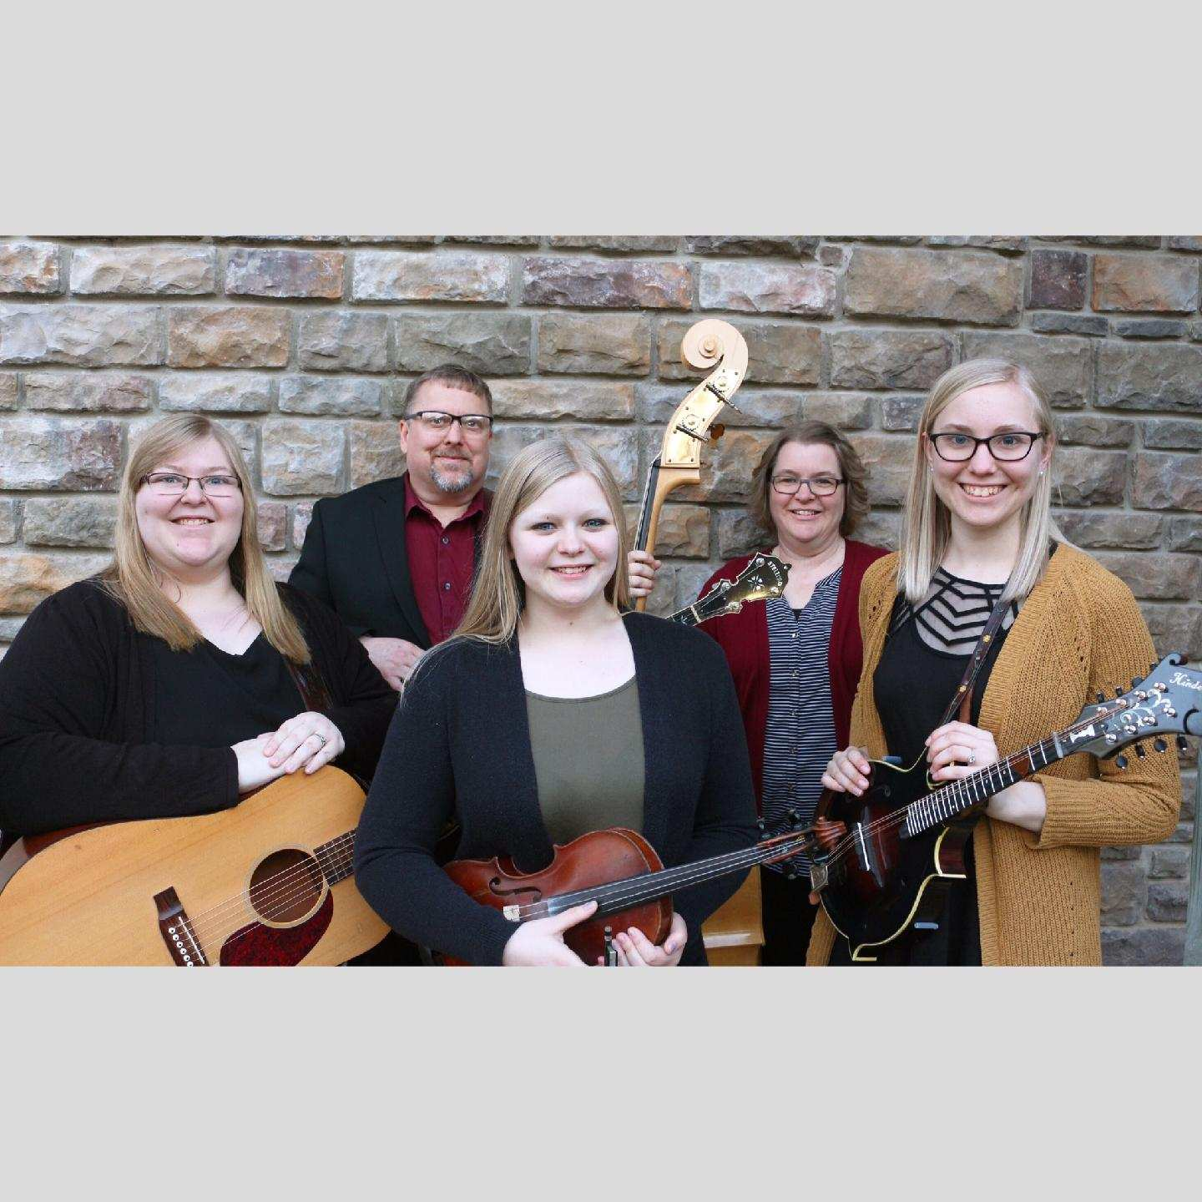

2016 Bluegrass Gospel Group of the Year – SPBGMA | 2017 Entertainers of the Year – BMAI

2017 Banjo Performer of the Year – BMAI | 2018 Songwriter of the Year – BMAI | 2018 Band of the Year - BMAI

Performing at:

Address:

Date:

Time:

For more information call: