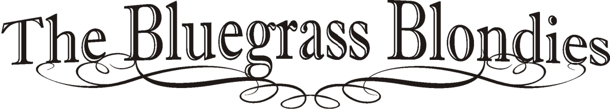

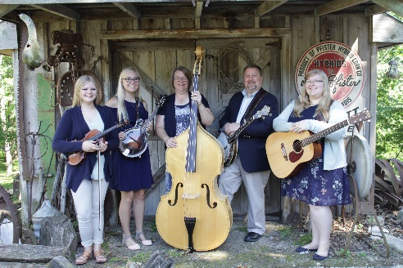 **Taylor (Amos) Robinson** is 30, teaching 8th grade English at Evans Middle School in Ottumwa, IA. Taylor plays guitar; sings lead, alto, soprano, high baritone. She enjoys songwriting and is currently writing her 43rd song – many of which the Bluegrass Blondies perform at shows. Taylor and husband, Gage, are busy with 3 girls (generation II “Blondies”) ages 5, 2, and 1. Bluegrass inspirations: Kenny and Amanda Smith, Allison Krauss and Union Station, The Isaacs, Dailey&Vincent, The Harper’s. Favorite places: Gatlinburg, TN; Silver Dollar City/Branson, MO; Backbone State Park/Strawberry Point, IA. Guitar of choice: Martin D-16. Taylor proudly endorses Blue Chip Picks, Martin SP Lifespan Medium Strings and Dan Clemons Custom Straps dba: Dan’s Saddle, Tack, Leather Shack. Recognitions include 2018 BMAI Songwriter of the Year.

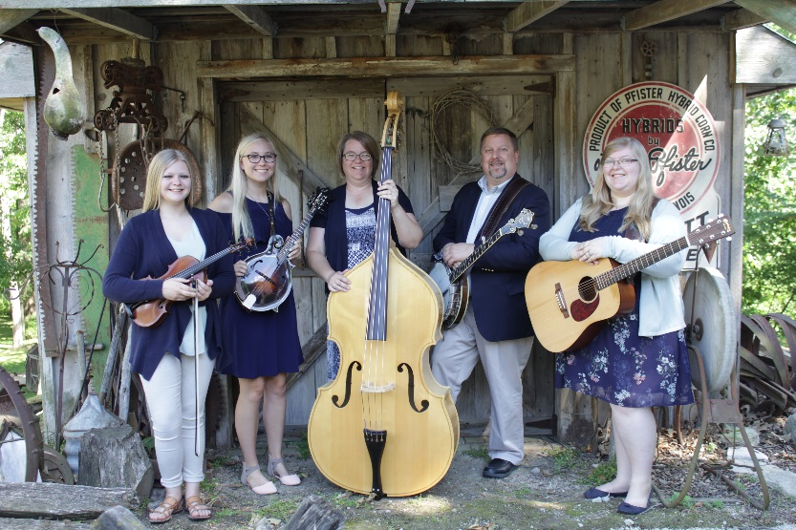**Bethany (Amos) Burns** is 27, teaching 8th grade math at Johnston Middle School. Bethany plays mandolin, fiddle, dobro, and guitar. Bethany sings lead, soprano, and high baritone. Hobbies include photography, cake decorating, anything art/craft. . Bluegrass inspirations – The Isaacs, Alecia Nugent, Rhonda Vincent, Dailey&Vincent, The Harper’s. Favorite places: Gatlinburg, TN; Silver Dollar City/Branson, MO; Orlando, FL. Mandolin of choice: Hinde Custom Mandolins. Bethany proudly endorses Hinde Mandolins, Blue Chip Picks and Dan Clemons Custom Straps dba: Dan’s Saddle, Tack, Leather Shack.

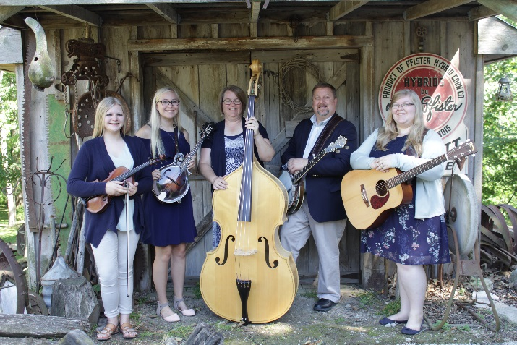

**Hallie (Amos) Polson** is 23 years old, is a Speech Pathologist Assistant, and is the proud momma of a 7 month old sweet blue-eyed girl, and a 2 year old 180% boy! Colt is already showing aptitude for Banjo 😉 Hallie plays fiddle, mandolin, and guitar. Sings lead, soprano, alto, baritone. Bluegrass inspirations – The Isaacs, Allison Krauss and Union Station, Dailey&Vincent, The Harper Family, and Rhonda Vincent. Country inspirations - Reba McIntire (huge fan), Brad Paisley. Favorite places: Gatlinburg, TN; Silver Dollar City/Branson, MO; Chicago, IL. Fiddle of choice: Jackson Guldane w / La Salle Carbon Fiber bow. Hallie proudly endorses The Bluegrass Shack, purveyors of the finest fiddles and accessories, and custom leather jewelry by Dan’s Saddle, Tack, Leather Shack.

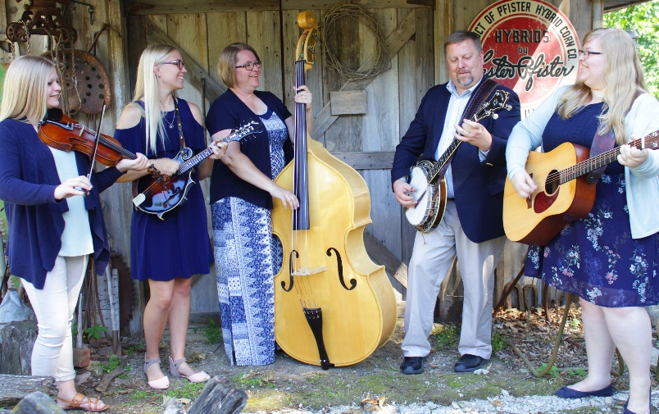

**Scott Amos** began his entertainment career in 1st grade, as a class clown, sacrificing honor, dignity and respect for the entertainment of others. This experience inevitably prepared him for the role as a banjo player. Now, a 46 year veteran of the performing arts, Scott’s resume includes performing with the Country Bluegrass Express (1985 - 1987), String Fever (1987-1991), a 20 year stint as the banjoist and MC for Bluegrass Addiction (1991-2011), 25 years as bassist/guitarist for the Glen Klyn Dance Band (1985-2010), as well as current projects as banjoist and consultant for The Bluegrass Blondies AKA The Amos Family Band (2008 – current) and Banjoist/MC for Grand Reunion, a Bluegrass Gospel/Southern Gospel group. As a promoter of Bluegrass and Acoustic Music, Scott is active in providing consulting services to acoustic music promoters/music events, as well as instructing guitar, banjo, mandolin, fiddle, dobro, bass, and vocal training to interested beginners across Southeast Iowa.

Recognitions include BMAI Banjo player of the Year 2017, and Iowa Bluegrass Hall of Fame inductee in 2015. Banjo of choice: Stelling 5-string Bellflower. Scott endorses Blue Chip Picks, Showcase 41 finger picks, D’Addario strings, and Dan Clemons Custom Straps dba: Dan’s Saddle, Tack & Leather Shack.

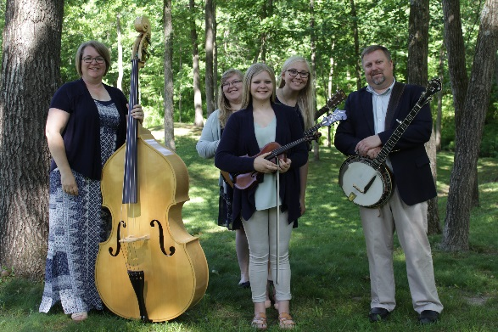

**Dawn Amos**, the literal “producer” of the Bluegrass Blondies, has recently retired from teaching second grade at Douma Elementary school for 33 years. She is an awesome cook, seamstress, gardner, and household manager. Dawn plays bass and sings with the Bluegrass Blondies. She enjoys sewing, scrapbooking, and quilting. Dawn is an avid race fan and enjoys attending NASCAR races and Iowa Hawkeye football games with her brothers. Dawn is active in the church, teaching Sunday school, VBS, cooking at various Bible Camps, sewing care bags for missions, and many other duties of an Elder’s wife. Bluegrass inspirations – The Isaacs, New Found Road, Barry Scott & Second Wind and Rhonda Vincent. Country/Christian inspirations - Rascal Flatts, Darius Rucker, Brad Paisley, For King and Country, Casting Crowns, and Mercy Me. Favorite places: Gatlinburg, TN; Silver Dollar City/Branson, MO; Bristol, TN; Rocky Mountain National Park. Bass of choice: Englehart ¾ upright bass. Dawn endorses Johnson&Johnson paper tape for blistered fingers.

The Bluegrass Blondies would like to thank their fans for many nominations and awards of recognition including 2018 BMAI Band of the Year, 2017 BMAI Entertaining Band of the Year, 2016 SPBGMA Gospel Group of the Year.

Discography: “The Bluegrass Blondies” 2008; “The Bluegrass Blondies” 2009; “Keep on the Sunny Side” 2010; “Bluegrass Favorites” 2011; “Gospel Favorites” 2012; “Just Be You” 2014; “Like My Mother Does” 2015; “Here I Am” 2016; “Blue” 2017. “Ramblin’ Train” 2020.

